YEAR 11 ECONOMICS
SEMESTER 1 EXAM
2018
MULTIPLE CHOICE
1 | A | B | C | D
2 | A | B | C | D
3 | A | B | C | D
4 | A | B | C | D
5 | A | B | C | D
6 | A | B | C | D
7 | A | B | C | D
8 | A | B | C | D
9 | A | B | C | D
10 | A | B | C | D
11 | A | B | C | D
12 | A | B | C | D
13 | A | B | C | D
14 | A | B | C | D
15 | A | B | C | D
16 | A | B | C | D
17 | A | B | C | D
18 | A | B | C | D
19 | A | B | C | D
20 | A | B | C | D
21 | A | B | C | D
22 | A | B | C | D
23 | A | B | C | D
24 | A | B | C | D

Section 2: Short Answer/Data Interpretation

Question 25
 | Description | Marks allocated
a) | Identify that it is due to the law of supply.  e.g. Quantity supplied increases as price increases, Vice Versa / direct relationship to price.  No MARK TO BE ALLOCATED IF THE STUDENT ONLY STATES LAW OF SUPPLY | 1
b) | PED measures the responsiveness of quantity demanded to a change in price | 1
c) | Calculation of PED  Point formula: 0.5  Mid-point formula: 0.714 | 1
 | State that it is inelastic | 1
d) | Given that potatoes have inelastic demand, when price increases, quantity demanded will decrease by a less than proportionate amount. | 1
 | Total revenue will increase when price increases | 1
 | Producers should increase their prices to maximise profit | 1
e) | Diagram – Drawn correctly with all axes labelled  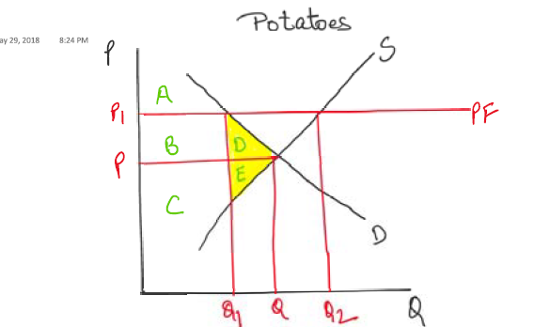 | 1
 | Description: (with reference to diagram)  - Price floor results in an increase in the price of potatoes from P to P1 which results in shortage in the market Q1-Q3  - CS decreases from AB to A,while PS decreases C to BC. This results in DWL of D&E  IF NO REFERENCE HAD BEEN MADE TO THE GRAPH, TAKE ONE MARK OFF. | 1  2
 | Link to efficiency  - As the increase in CS is less than the decrease in PS, there is a deadweight loss in the market causes by overall loss in total surplus. The market is inefficient. | 1

Question 26
 | Description | Marks allocated
a) | The lead time for orders is a year | 1
b) | Product market – The market for final goods and services like microwaves OR ANY OTHER RELEVANT EXAMPLE. | 1
 | Factor market – The market for factors of production like cotton, OR ANY OTHER RELEVANT EXAMPLE | 1
c) | Diagram – Correctly labelled and shows shift of demand curve  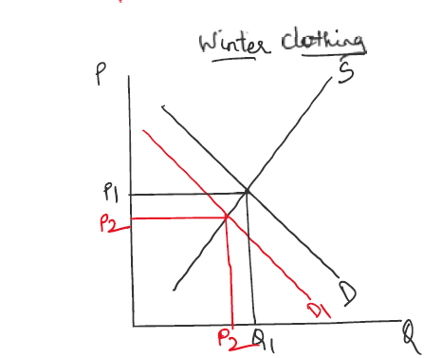 | 1
 | Identifies the cause of the shift in the demand curve correctly:  - Reduction in tastes and preferences so reducing demand for winter clothing  - Demand decreases, as seen in a leftward shift of the demand curve | 1
 | Identifies the impact of the change in demand (with reference to diagram):  - Price decreases to P1  - Quantity demanded decreases to Q1 | 1
d) | Identifies 3 factors impacting demand for winter clothing with description/ examples, | 2x3=6
 | - Weather- in winter demand will increase
 | - Level of disposable income: As income levels increase, the quantity demanded for winter clothing would increase
 | - Tastes and preferences: If consumer preferences shift towards winter clothing, then the demand for winter clothing will increase. However, if consumer preferences shift away from winter clothing to summer clothing as outlined in the excerpt, then demand for winter clothing will decrease
 | - Expectations- wage rise may not happen and therefore less likely to spend money on new winter clothes
 | - Any other reasonable factor

Question 27
 | Description | Marks allocated
a) | Define - Demerit goods have an external negative effect associated with their consumption/production | 1
 | The consumption of soft drinks is a demerit good as it causes negative impacts like obesity which have an overflow effect on the health system | 1
b) | Diagram correctly drawn and labelled | 1
 | Explains a negative production externality with reference to the diagram, i.e. MSC>MPC | 1
 | Explains impact of negative production externality in relation to price and quantity | 1
 | Explains that a negative production externality causes overproduction, which is an inefficient allocation of resources and so causes a deadweight loss (potential welfare gain) as indicated in the diagram. | 1
 | Note: Students should refer closely to their diagram
 | Max 2m if NCE drawn
c) | Diagram:  - Correctly drawn elastic demand curve  - Correctly draws the impact of the tax | 1  1
 | Explains the impact of the tax with reference to the diagram:  - Leftward shift of supply curve as the tax increases cost of production. Supply decreases from S to S1  - Details impact of tax with relation to price and quantity  - Identifies that the tax causes a deadweight loss due to decrease in total surplus  Okay to explain from POV of internalisation | 1  1  1
 | Distinguishes between impact on consumers and producers:  - The tax burden falls on producers  - The decrease in price received by producers is greater than the increase in price paid by consumers | 1

EXTENDED ANSWERS
QUESTION 28
DESCRIPTION | MARKS
A  - Define competitive markets and state two features. For eg- Large number of buyers, Price Makers etc  - Define Efficiency  - Graph showing CS, PS and Equilibrium 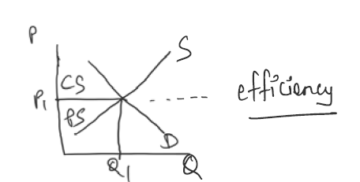  - Explain the graph linking it to CS, PS and Efficiency. | 2  1  1  2
B  - Using examples Define Market Power  - Define Equity  - Example, graph, explanation  - Impact on efficiency and equity leading to the impact on CS, PS  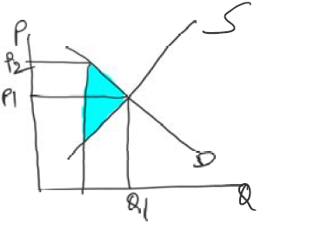 | 2  1  3  2
c.  - Define ACCC- helps in increase in competition and efficiency  - Any four examples – outline and explain ( eg- Cartel) | 2  4

QUESTION 29

DESCRIPTION | MARKS
A.  - ANY THREE FACTORS- ONE MARK FOR OUTLINING AND ONE MARK FOR EXPLAINING USING AN EXAMPLE  Substitutes, Time, Disposable Income or Any other relevant example | 2X3= 6
b.  - Define Price elasticity of Supply  - Graphs- elastic and Inelastic-  - explain inelastic with examples  - explain elastic with examples  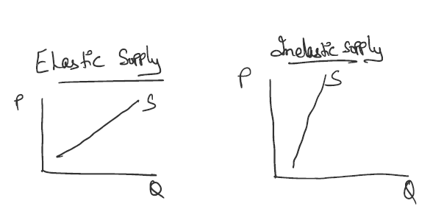 | 1  1  2  2
C.  - Define- Normal goods, Sustitutes, Inferior goods, Complementary goods with examples.  - Explain Income elasticity of Demand  - Explain Cross elasticity of demand | 1x4=4  2  2

